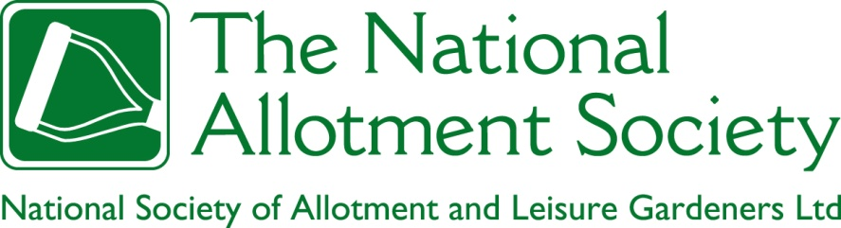

NAS Policy Document 110. Social Interaction on Allotment Sites
1. The Society recognises that allotment sites can be sociable places, populated by people who share a mutual appreciation of gardening. The Society encourages activities that further the development of social interaction and a sense of community on allotment sites. At the same time, the Society recognizes that allotments are both public and private places, within which some tenants may wish to be left to garden in peace. The Society recognises the right of any tenant gardening in compliance with their tenancy agreement to the quiet enjoyment of their allotment garden, a right that is violated by any form of unreasonable interaction within or across the boundaries of that individual’s allotment garden.

2. Where disputes between tenants arise, or between tenants and site managers, the Society respects the autonomy of the organisation responsible for site management to resolve the dispute, with the caveat that transparent policy and documentation (including an independent appeals process) should be in place, including policies covering forms of antisocial behavior such as abuse, threats and violence, however expressed.

3. The Society maintains that responsibility for the behaviour of any person who is invited onto an allotment garden by a tenant lies with the tenant, and that this principle should be included in the tenancy agreement. This principle applies both to members of the tenant’s family of whatever age and to third parties such as informal garden sharers.

4. The Society recognizes the value and importance of good social relations between allotment associations (and individual tenants) and parties external to the allotments, including neighbours, sympathetic individuals and organisations, and institutions with the power to help protect allotment sites. It encourages the controlled and well-managed opening of allotment sites to facilitate such relations, subject to recognition of the rights of individual tenants and appropriate arrangements for insurance.

